Unit Time Management (Speakers: Mr. Tom Vinciguerra, Professional Consultant; and Ms. Jamie Dicks, Middle School Teacher, Delhi Middle School; July 23, 2015, 9:00 am–10:30 am)
For 33 years, Mr. Tom Vinciguerra has worked in numerous engineering technical and operational capacities at various pharmaceutical companies. His last work experiences include Director of Operations at Patheon Pharmaceuticals when he retired to professional consulting. Mr. Vinciguerra received a degree in BS Chemical Engineering from UC in 1976 and started his professional career with his coop company, Merrell Dow Pharmaceuticals. His professional areas of expertise include operations management, strategic planning, engineering, training and career development. Mr. Vinciguerra is a proud father of 2 chemical engineers, his daughters.
Ms. Jamie Dicks is in her seventh year of teaching at Delhi Middle School in the Oak Hills Local School District. She has a bachelor’s and master’s degree in middle childhood education with specializations in math and science for grades four through nine. She worked for three years in West Clermont Schools and is in her fourth year at Oak Hills. She was a member of Cohort 2 in the CEEMS program at UC.
Mr. Vinciguerra began with a discussion of the purpose for this presentation by asking participants to reflect on past experience with implementing CBL / EDP lessons: Did the time drag on? Did technical difficulties distract from the learning? Mr. Vinciguerra also commented that since these units will be shared on the Internet for anyone, it is good to revise them to improve quality as much as possible. The purpose of the talk was to offer practical suggestions for organizing and managing CBL units successfully.
Mr. Vinciguerra challenged participants to think about the Engineering Design Process as it applies to unit designing and planning for the classroom. Presenters organized their slides to follow the steps of the EDP, such as “Step 3 - Selecting Solutions” and “Communication.” Presenters also alternated between presenting information and allowing teacher participants to reflect, write and share in small groups using a reflection handout.
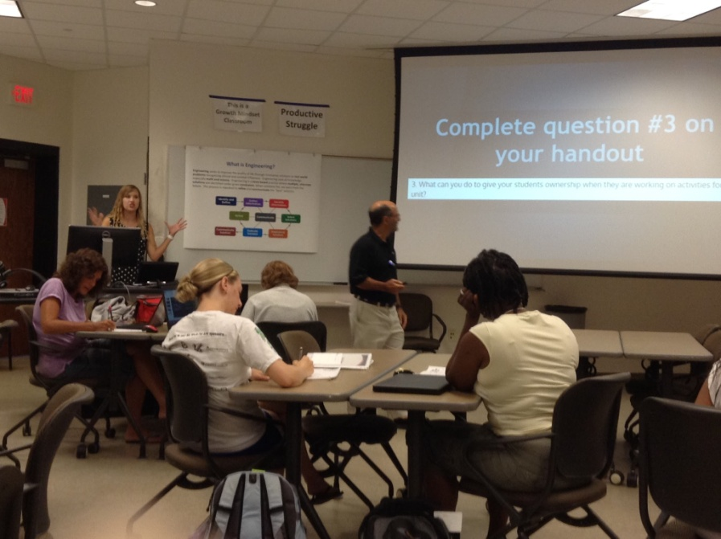
Figure 1: Ms. Dicks and Mr. Vinciguerra Instructed Participants to Use the Handout for Reflection and Small Group Discussion Throughout the Presentation
Ms. Dicks shared some slides on establishing a unit timeline, if a teacher realizes they do not have enough class time for the unit. She suggested teachers consider these questions and suggestions:
- Can you provide more ‘givens’ or discrete guiding questions?
- Can the unit activities be divided among the teams for a class Collaborative challenge?
- What really doesn’t support the objective - should be cut?
- Don’t shortchange student discovery!!
- Use the resource team for advice if the unit needs to be cut shorter.
- Generate timeline summary with Key Unit Milestones
- Consider scheduling so resource team can visit during a worthwhile activity to observe
A discussion followed between presenters and participants about creating and monitoring student teams. Presenters and participants proposed using team names, deciding on grouping in advance, using “Secondary Seats” for middle schoolers, and using a beginning-of-the-year inventory to help sort students. Suggestions were also given on the topic of giving students ownership. Suggestions included giving each student on the team a specific job (recorder, team manager, materials manager - students responsible for gathering materials and putting away) and posting the unit timeline for students to own. Ms. Dicks shared an online resource for creating Team Work Rubrics called, Rubistar, so teachers can have team members evaluate each other as part of their grade, and should share before the challenge so students are aware of the criteria.
For time management, how do you know when to stop an activity? Ms. Dicks gave the participants these tips:
- Think about the standard -- will giving more time contribute to them learning this standard?
- Give students checkpoints and help teams move forward faster if they are behind everyone else.
- Use a timer
- Providing website lists for middle school helps reduce time
- Folder online for students to access from home to save even more time (Schoology, Edmodo)-- upload and access completed work to folder
- No computer access? Keep a folder or binder for each group in the classroom (not to be left at home or with the sick person)
- Consider their computer skill level
- Plan if additional hands needed (coaches, fellows, etc.)
- Provide extensions for teams that are ahead
Ms Dicks reminded the participants that student research is a key part of the engineering project. The student research step should not be skipped to save time.
Keeping a Teacher Unit Log was suggested by Mr. Vinciguerra. This allows teachers to record their reflections and make recommendations for changes--teachers could use Post-its, take notes electronically, and take notes as you go. Teachers were encouraged to note changes and issues on Unit Documents and to complete the activity reflection on the templates the same day that the activity is done in class.
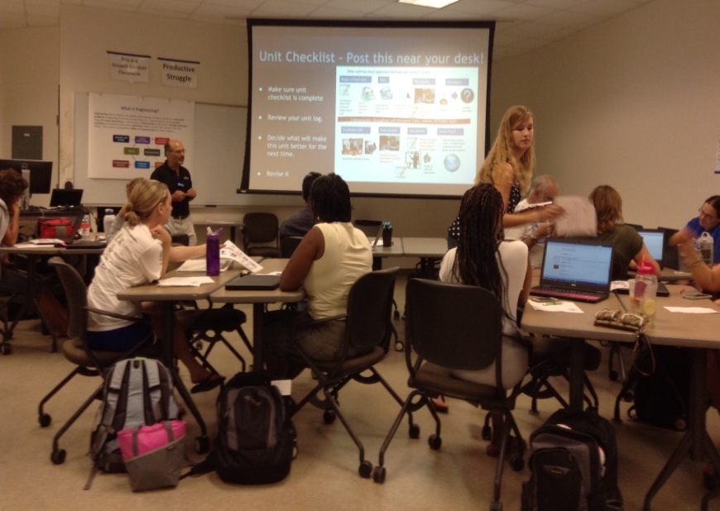
Figure 2: Ms. Dicks Passed Out Copies of the CEEMS Unit Checklist as Mr. Vinciguerra Explained How the Checklist Could Be Used
The importance of communication with resource team was stressed (this is also an important component of the EDP). Several ways to use the resource team were offered. Teachers were encouraged to initiate communication, put the school schedule on their Wikis, provide wireless password for school network, and introduce the team member at class visits. It will also be important to respond to email, phone, text etc. in a timely manner, follow up with communication on lesson, schedule visits (planning, observation, debrief) and agree on the method (Skype, Hangout), keep the self-evaluation checklist up to date, and make arrangements for the debrief meeting to reflect and collect feedback Ms. Dicks recommended keeping things organized on the Wiki and showed how she puts her school lesson plan on a Google Doc so changes she makes are automatically updated on the Wiki) Mr. Vinciguerra recommended that teachers use “Track-Changes” as documents are updated to help focus on revisions and comments for efficient review. Coaches will also be important resources for a Post-Unit Review. In conclusion, participants were asked to remember: “Teachers around the world may be using your unit! Make it one you can be proud of!”
The workshop offered a lot for participants to learn. Because the workshop allowed participants to repeatedly reflect on their own units and write down suggestions, each participant had the opportunity to identify the areas where they would need to focus in terms of organizing and implementing the unit. Participants were able to leave the workshop with concrete suggestions for how they could improve their unit or implement it more effectively. For example, making communication and student ownership high priorities were important takeaways.

